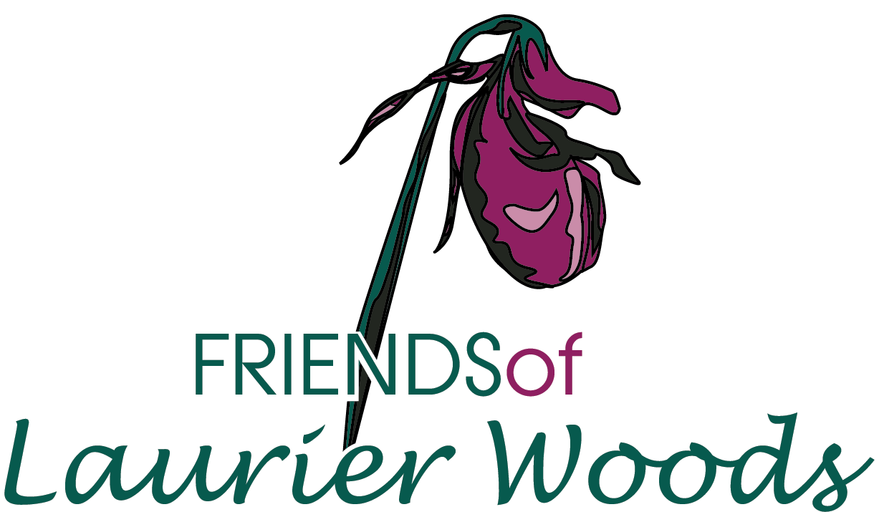

MEMBERSHIP

YES, I am interested in supporting Laurier Woods.

I am interested in…

- Purchasing an annual membership (Individual $20, Family $30)
- Serving on the Board of Directors
Please note your membership is for the current year (January - December). Annual renewal notices are sent out by email in late January, with payment due prior to the Annual General Meeting (usually held in April).

Enclosed is my cheque, made payable to “The Friends of Laurier Woods”, in the amount of $

NAME:

ADDRESS:

EMAIL:
(optional – but a great way for us to stay connected)

TELEPHONE:

Please mail to: The Friends of Laurier Woods
c/o North Bay-Mattawa Conservation Authority
15 Janey Avenue
North Bay ON P1C 1N1

THANK YOU for your support!

